3.2 The design and implementation of desktop version user interface

3.2.1 Frame Structure
Given an overview of the developed source code hierarchy as following. Firstly, there is a window interface including a menu, a chessboard, a record board and a function button. Secondly, the chessboard controls pieces and records their locations. Thirdly, the record board not only notes each movement down but also shows tips and search results. Last, the engine is packed as a thread running before each step is done. The UI design is not only considered about the feasibility and practicality, but also appearance according to other excellent designs (Jojo. Y, 2015).
3.2.2 User Interface
Desktop version use Eclipse as tool and mainly use Java language. Swing and Awt packages in Java constitute the whole GUI for desktop part. Desktop version GUI mainly has four parts, menu, chessboard, button and record board, as showing in Figure 4.2.1.1.
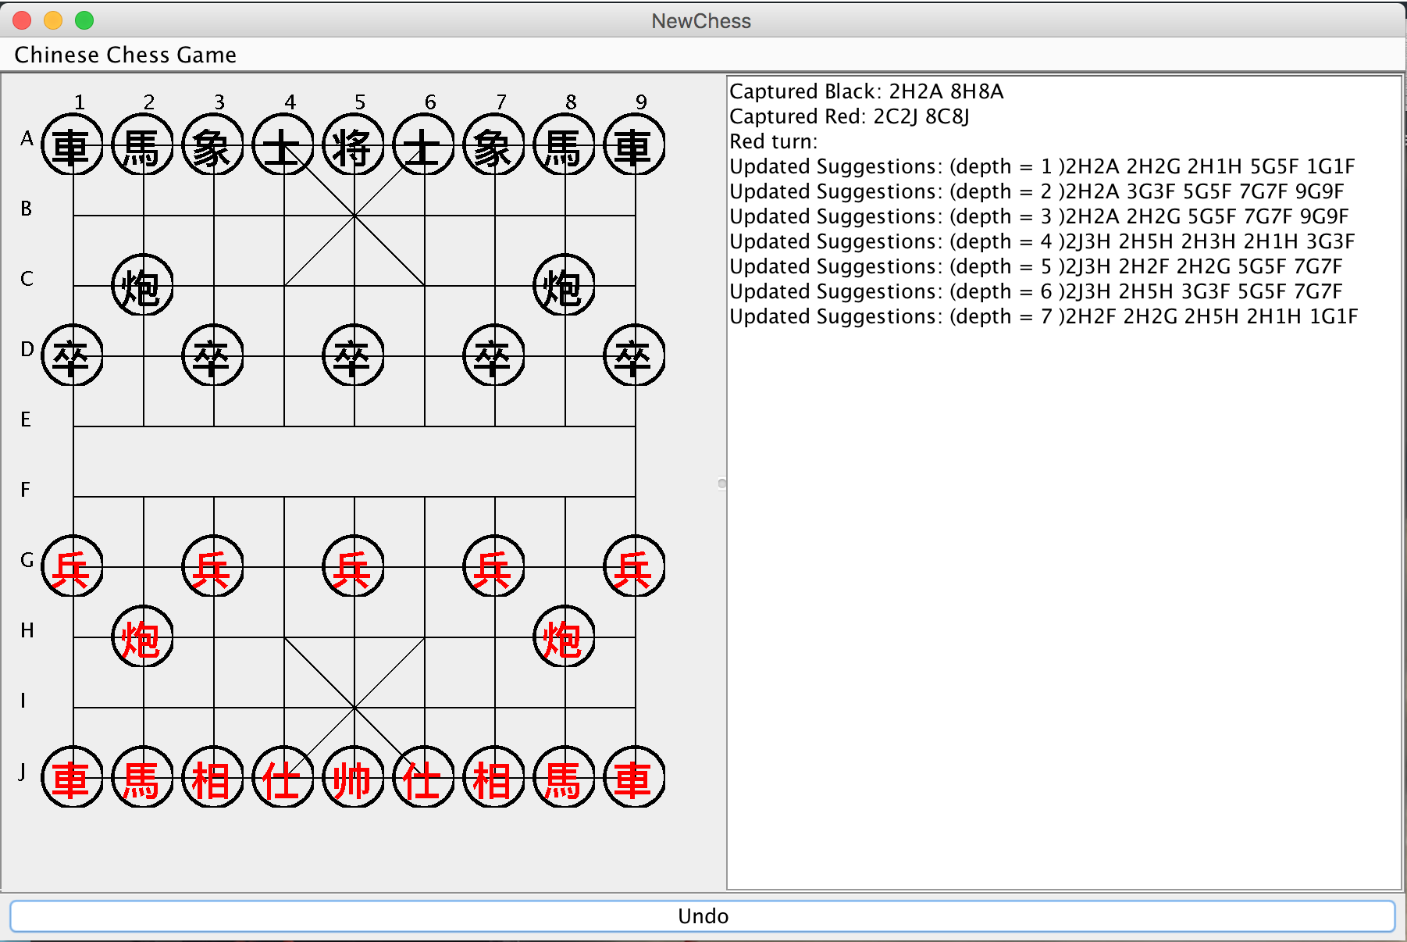
Figure 4.2.1.1

In the upper left corner, there is a menu bar, in which user can exit or restart game in the menu.
The left half of the middle shows the graphical chessboard. After a lot of research, most chessboards use numbers or alphabets (Bodlaender, H. and Duniho, F., 2014). Some prefer to lowercase letters and some prefer uppercase letter. Use ‘A’ to ‘J’ and ‘1’ to ‘9’ to give a certain and clear point in the board when the history points are listed. A game of Advanced Xiangqi has two sides, one is black and one is red. As the rule shows, red goes first and user could choose any side. If user moves piece invalid or chooses wrong side, there is an alert window and then give a warning on it. When we click one piece, the color will change to blue to tell users that they have got a clicked piece .

Right half one is the record board, containing these pieces, that would be captured, next movement tips and this turn color.

In the bottom of the interface, a “Undo” button can delete the last move step in the history and move the last moved piece back.

3.2.3 Code hierarchy Development

3.2.3.1 Chessboard
This advanced Xiangqi game is like to other board games, including graphical interface, a changeable board and an engine. There are three chessboards are used in these aspects.

As for the graphical chessboard, simple lines are draw in the graphical interface. Most chess games adopt images to show because of their beautiful UI, even using 3D images. Compared to this method, lines are needed more calculation and testing. What more significant is that Swing also can create the board, after which is learned in last semester. The second board uses a normal 2D-list. Each coordinate has its “Point”, which might has piece on it.

3.2.3.2 Chess Piece & movement
Similar to the chessboard style, a circle and a Chinese word make each piece through Swing method. Same to the chessboard, piece images are applied to the Android version.

In the case of that, clicking event responses when the mouse clicks in the rectangular area that as the circle center as the same center and uses the diameter of the side length. In contract to image clicking, “Rectangle” makes code more complicated. Each movement would be record in the “ArrayList”, after being tested in rule system. Likewise, engine would start the thread after completion of one movement. That is because of “Undo” function and graphical changes.

3.2.3.3 Record board Content
As long as the game starts, record board would start to show engine searching result and those pieces that might be being captured in next turn. In terms of engine thread, record board would add one suggestion on after which engine has searched one depth deeper. This kind of record board is not equipped in almost online advanced Xiangqi games. As the saying goes, “One cannot serve God man Mammon”. It is not easy to meet the requirements for the beautiful interface and the required functions. In order to list more suggestions and reminders, player can wait more time. After the testing, it usually takes 10 seconds to do Depth-First-Search which depth equals to 5. About 1-2 minutes, depth would increase to 6-7. With the dramatically growth of search size, suggestion would appear much slower.

3.2.3.4 Undo Button
Undo button is the only button applied in the interface, which could be used for testing or operating miss that player takes back moves. In the traditional advanced Xiangqi game, there is no chance to take pieces back, even operating mistakes. In terms of the friendly interaction, this function is designed. Here is to point out that the little difference between real game rule and desktop version rule.

This “undo” function deletes the last movement recorded and restore to the original state. Reminder words would appear in the record board to avoid you still want to repeat this movement. It is no direct correlations with engine but still need to call undo function in engine. Once calling the engine, the thread has to stop then restart.

3.2.4 Modifications
With in-depth understanding of advanced Xiangqi and the functions users needed, how to use scientific methods, requirements also change or become obsolete. This paragraph mainly introduces the original design and final output including modifications and their reasons.

3.2.4.1 Interface graphics
In the original design, the first modification is that there are only a few reminder words for players. Considering the suggestions output, we have to build a wider board to contain these tips.
Secondly, buttons are designed to foresee the next three steps, check selected piece possibility and give a feedback, give the next step advice from the temporary chessboard situation and undo last movement respectively, each named “Show”, “Check”, “Search” and “Undo”. From their usage, it is easy to figure out that “Show” is similar to “Search”. Consequently, two buttons are combined and only remain “Search” which is based on the “Show” result. Because it is difficult in measuring the feedback in the “Check” button that how to evaluate and what criteria to define.

3.2.4.2 Thread running
Due to the unpracticed running multi-thread in the Java files, single thread was adopted as other before work done. In the case of that, only clicking buttons can make engine run. Eventually, multi-thread between engine and UI surface is used, after being suggested from supervisor Paul.

3.2.4.3 Details added
The easiest-to-use and most intuitive feedback is the graphics in the interface. Obviously the piece circle color could be changed easily, perhaps is precisely because of this reason, highlight clicked piece is added in the final version. Similarly, pop-up boxes with information also could give direct response for players.

In the record board, movement contains specific coordinate, piece name and colour while suggestion updated only has coordinates. Because the numerous pieces mentioned, it is not appropriate in the same way. After repeated comparison tests, coordinates are remained and other unnecessary information is declined.

3.2.5 Problems
Even though making a great effort on this programme, there are still some problems on desktop version. It would be discussed in two different situations, one is bug remaining and the other is not found which likely to Page 404.

3.2.5.1 Problems remaining
To be honest, desktop version goes through the longest time and indeed has enough time to debug all problems have been found. Some outcomes are not ideal as expected. The first to point out is that the UI design is not beautiful only using Swing, not to mention the hideous colour. The second is the output in the record board and this version is the most concise and clear style. Then, with regard to codes, some useless code should be cut and variables used should be narrowed down even further. In the case of that, the structure of the whole programme is not reasonable. For example, it needs ArrayList to record moved pieces and their locations for the “undo” function. Because the limited variables used in ArrayList, we have to create two ArrayList to record the moved piece and captured piece information including name, color and coordinate.

3.2.5.2 other problems
There is a saying goes “Practice makes perfect”. Even though inexperienced skills are trained much better now, there are still some suitable or use-friendly places needed to improve. There are some examples listed as following.
- Chess piece looks ugly but no solution we found.
- The English explanation seems good but not concise enough.
- When player clicks “Undo”, the thread with engine could not continue the former searching but restart which would cost some unnecessary time.

References:
Jojo.Y 2015
http://www.techsupportalert.com/content/best-free-computer-chinese-chess.htm

